Article Updated:January 7th, 2021

2021 IRS Tax Deductibility Amounts Announced
As a way to encourage more people to plan for the financial costs and burdens of aging, the federal government has made several tax benefits available. The Internal Revenue Service (IRS) announced its annual inflation adjustments for the tax year 2021 for taxpayers eligible to deduct the cost of qualified Long-Term Care Insurance policies. These numbers also apply to the eligible amount of an LTC Insurance premium reimbursable by Health Savings Accounts or an employer-funded Health Reimbursement Account (HRA). Long-Term Care Insurance has attractive tax treatment under IRC 7702(b). Premiums can be tax deductible if you have enough medical related deductions, you are self-employed or own an LLC, S-Corporation, or C-Corporation. Individual taxpayers are allowed to deduct the cost of their policy (and that of a spouse) as part of their medical expense tax deduction. Medical expenses that exceed 10 percent of adjusted gross income are eligible.

Tax Incentives for Self-Employed and Businesses Available
Those who are self-employed (file a schedule C) or own an LLC, S-Corporation, or C-Corporation have more extensive deductions. This also applies to eligible spouses. Regular C-Corporations can deduct 100% of the premium. Otherwise, the IRS publishes a chart each year that shows the amount deductible based on age.
This chart will apply to all other corporations, self-employed individuals, and individual taxpayers as part of their eligible medical expenses. If you own a business and have employees, you do not have to offer this benefit to anyone other than yourself, unlike other insurance benefits. However, you can elect to offer Long-Term Care Insurance to certain individual employees as a “golden parachute” benefit.

The IRS has Increased These Amounts for 2021
Age at end of 2021 | 2021 Limit | 2020 Limit
40 or less | $450 | $430
41 - 50 | $850 | $810
51 - 60 | $1,690 | $1,630
61 - 70 | $4,520 | $4,350
More than 70 | $5,640 | $5,430

Benefits Generally Tax-Free
Tax-Qualified Long-Term Care Insurance benefits are generally tax-free. However, some policies pay a cash amount or indemnity once you qualify for benefits. The tax-free maximum allowable amount for 2020 is $400 a day, or the actual cost of care, whichever is higher.

Health Savings Accounts
Many employers are offering Health Savings Accounts as a way to lower the cost of health insurance. Many people are unaware that the pre-tax money in a Health Savings Account can be used to pay for qualified Long-Term Care Insurance premiums. The amount that is reimbursable through your HSA is based on the IRS chart depending on your age. The IRS also announced new, higher HSA contribution limits for 2021. You can contribute $3,600 for individual coverage for 2021, up from $3,550 for 2020, or $7,200 for family coverage, up from $7,100 for 2020.
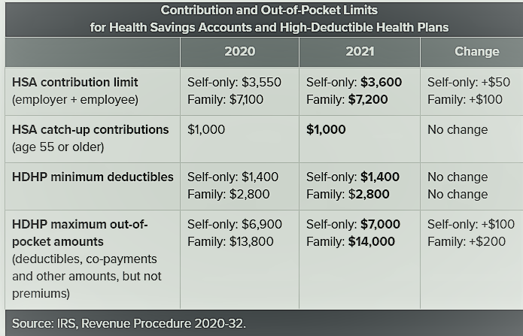
Employer HSA contributions are not treated as taxable income but do count toward employees' annual contribution limit.

What Happens After Age 65?
Once you turn age 65, you can use the funds in the HSA in any way you wish. While you are no longer required to use the HSA funds only for qualified health care expenses and Long-Term Care Insurance premiums, many people will often continue to do so since the money comes out tax-free. Plus, you get to use the pre-tax money in the account to also pay for your Medicare Supplement.

Some Hybrid Policies Have Additional Tax Advantages
Other types of policies exist which have more limited tax advantages, including asset-based or "hybrid" policies. These plans are life insurance policies or annuities with riders for long-term care. In addition to the long-term care benefit, there is a death benefit. Since these plans follow federal tax guidelines (IRC 7702(b), a portion of the premium dedicated to long-term care may be deductible. The benefits from hybrid policies, like traditional Long-Term Care Insurance, come tax-free. However, life insurance policies which have a chronic illness rider (IRC 101(g), just accelerate the death benefit when a person meets the benefit trigger. IRC Section 101(g) riders will sometimes provide accelerated death benefits upon either terminal illness or chronic illness. In some cases, they require a chronic illness to be terminal or with zero chance of recovery. Some of these policies also exclude benefits for cognitive supervision. These plans would not be eligible for tax deductions. Limited duration, or short-term plans, which provide a one or two-year long-term care benefit, also are not generally deductible. Still, their benefits remain tax-free based on actual expenses being incurred.
Always consult a professional tax advisor to review your specific situation.

Rate Stabilization Rules for Today's LTC Insurance
Today's Long-Term Care Insurance is not only affordable but is rate stable. Rate stabilization rules are in place in most states. Today's policies are priced based on the extreme low-interest-rate environment that adds additional rate stability. The chance of future premium increases in the future is small. Without Long-Term Care Insurance, you will pay for future long-term health care from income and savings, or your family will become caregivers. In some situations, you may have both paid care and family caregivers. Neither option is ideal, and the consequences on family and finances can be enormous. Affordable Long-Term Care Insurance safeguards your retirement accounts (401(k) IRA SEP) and other assets as it reduces the stress otherwise placed on your family members.

Cost of Long-Term Health Care Depends on Where You Live
The cost of long-term health care is very expensive but varies depending on the type of care and where you live. The best time to obtain coverage is well before your retirement, ideally in your 40s or 50s, to take advantage of low premiums and the most affordable options. Since there are many options and types of available plans, you should seek a qualified Long-Term Care Insurance specialist to help you navigate these options and help you find the best coverage at the best value.

